In general:

* Smaller footprint is better for kitchen space
* think vertically
* Shelving unit

|  |  |
| --- | --- |
| Pros | Cons |
| May use plastic or metal |  |
| Efficient footprint | Separate insulation |
| Possibly premade |  |
| Spacious |  |
|  |  |
|  |  |
|  |  |

* 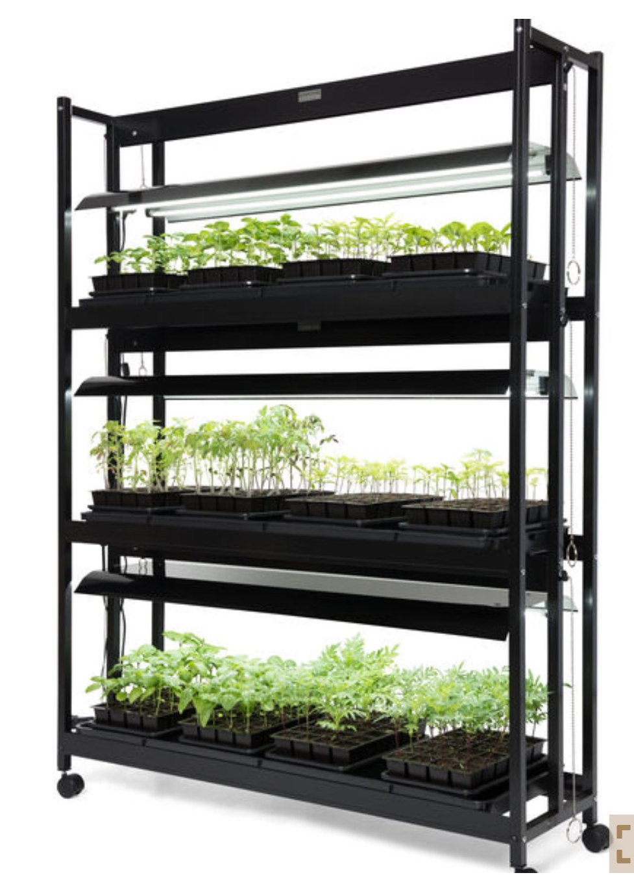
* PVC

|  |  |
| --- | --- |
| Pros | Cons |
| Cheap | No insulation |
| watertight | weak |
|  | May be hard to clean |
|  | Requires separate containers for electronics and water storage |
|  |  |

* 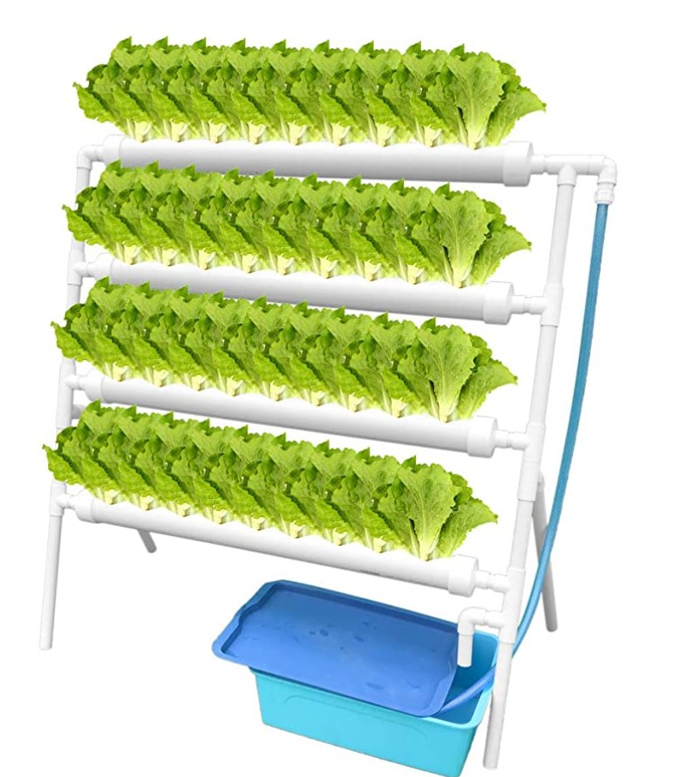
* Tent
* 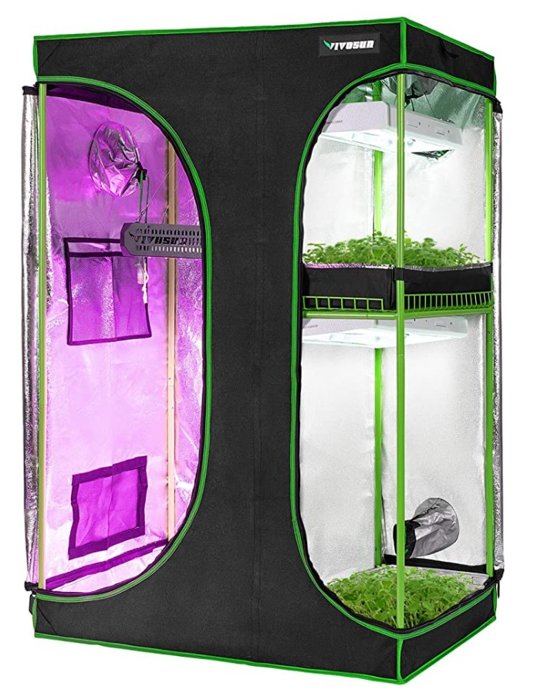

|  |  |
| --- | --- |
| Pros | Cons |
| Somewhat insulated | Insulation may not be very good |
|  | Not super durable |
|  |  |

* Modular - not even really structural
  + Shoebox idea, multiple boxes for different plants, buy 1 or 10, connect easily
* 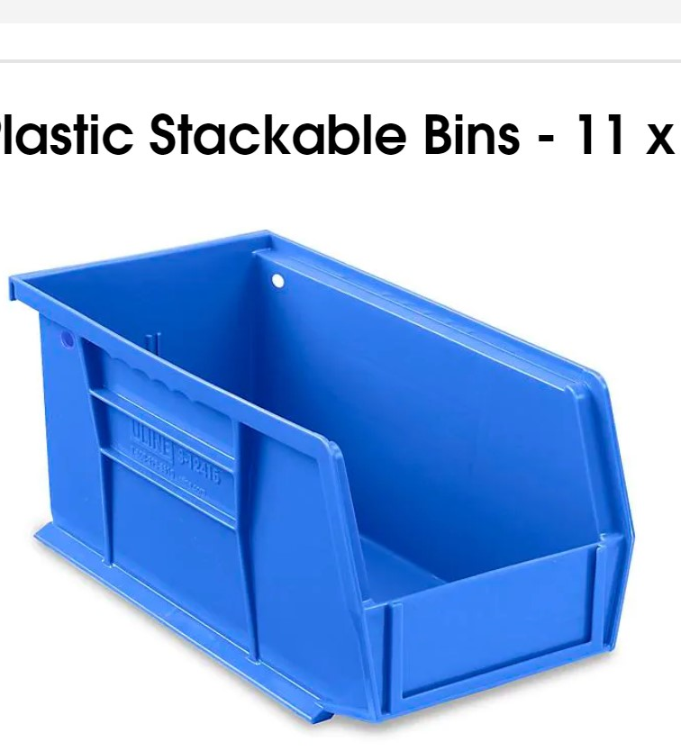

|  |  |
| --- | --- |
| Modular |  |
| Compatible with grow mats |  |
| Water tight |  |
| cheap |  |
|  |  |

Cabinet/drawers

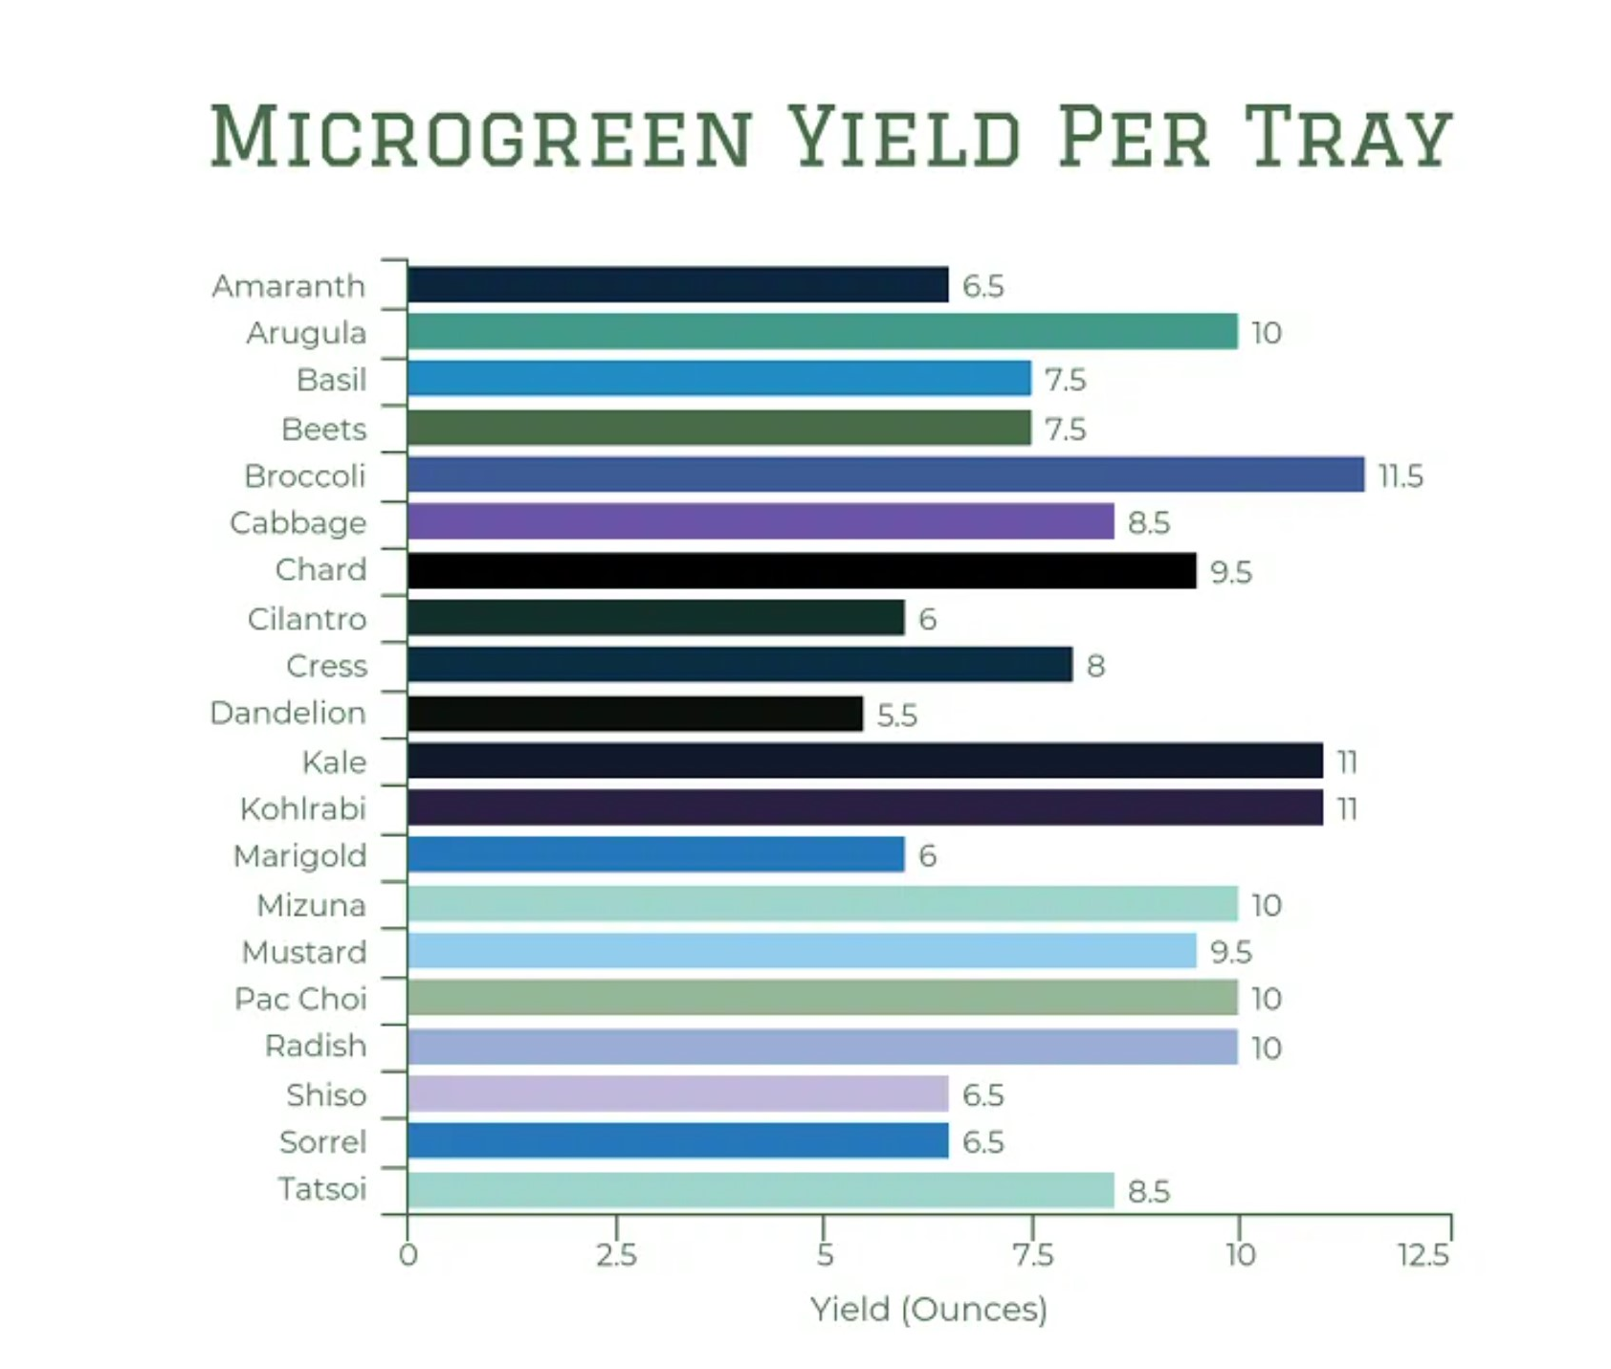<https://gardengearshop.com/microgreens-yield-per-tray/>

Broccoli: 11.5 oz per 10” by 20” tray = 200 in^2

(5 – 9 oz) per 1020 tray https://www.urbanfarming.com/broccoli-microgreens/

1 cup = 1-1.5 ounces (based on a cup of spinach)

~8oz yield per 200in^2

~5-7 cups per 200 in^2

~33 in^2 = 1 cup of yield